Output Parsers in LangChain | Generative AI using LangChain
https://www.youtube.com/watch?v=Op6PbJZ5b2Q&list=PLKnIA16_RmvaTbihpo4MtzVm4XOQa0ER0&index=8
https://github.com/campusx-official/langchain-output-parsers/blob/main/jsonoutputparser.py
00:00 – Intro
01:10 – Recap
04:04 - Output Parsers
06:28 - Str Output Parser
21:40 - JSON Output Parser
32:50 - Structured Output Parser
42:04 - Pydantic Output Parser
1. Introduction
1.1 Video Context
This video is closely connected to the previous session on Structured Output in LangChain.
To fully understand this topic, it is recommended to first go through the earlier video on structured output.
1.2 Objectives of This Video
In this session, the focus is on:
- Understanding what Output Parsers are
- Why Output Parsers are required
- Learning the four most important Output Parsers in LangChain
- Understanding how and when to use each parser
- Working through complete code examples
The four Output Parsers covered are:
- String Output Parser
- JSON Output Parser
- Structured Output Parser
- Pydantic Output Parser

2. Recap: Structured Output
2.1 Nature of LLM Responses
When interacting with any Large Language Model (LLM), the default response is:
- Text-based
- Unstructured
This means the output has no fixed schema or format.

2.2 Issues with Unstructured Output
Unstructured text cannot be directly used with:
- Databases
- APIs
- Other automated systems
Since these systems expect data in structured formats.

2.3 Concept of Structured Output
Structured output forces the LLM to respond in a defined format such as:
- JSON
- Objects with schema
- Validated structures
Example:
{
"topic": "Black Hole",
"summary": "A black hole is a region of space where gravity is extremely strong."
}

2.4 Benefits of Structured Output
Using structured output allows:
- Easy database insertion
- Smooth API integration
- Better automation

3. Types of LLMs Based on Structured Output Support
3.1 Models That Support Structured Output by Default
These models are fine-tuned to generate structured data when instructed.
Examples include:
- GPT models
LangChain provides a helper function:
with_structured_output()
to directly work with these models.

3.2 Models That Do Not Support Structured Output Well
Mostly open-source models such as:
- HuggingFace models
- Local LLMs (e.g., TinyLlama)
These models:
- Are not well fine-tuned for structured responses
- Often break JSON or schema formats
For such models, Output Parsers are required.

4. Output Parsers in LangChain
4.1 Definition
Output Parsers are special LangChain classes that:
- Take raw LLM responses
- Convert them into structured formats such as:
  - String
  - JSON
  - Pydantic models
  - Other schemas

4.2 Key Features
Output Parsers ensure:
- Consistency
- Validation
- Ease of use in applications

4.3 Compatibility
Output Parsers can be used with:
- Models that support structured output
- Models that do not support structured output
They work seamlessly with both.

5. Common Output Parsers in LangChain
The most commonly used parsers are:
5.1 String Output Parser
5.2 JSON Output Parser
5.3 Structured Output Parser
5.4 Pydantic Output Parser
Other available parsers include:
- CSV Output Parser
- List Output Parser
However, most use cases rely on the four listed above.

6. String Output Parser
6.1 Overview
The String Output Parser is the simplest parser.
Function:
It extracts only the textual content from the LLM response and returns it as a clean string.

6.2 Default LLM Response Structure
When calling an LLM, the response contains:
- Main text content
- Token usage
- Metadata
Typically accessed using:
result.content

6.3 How String Output Parser Improves This
With String Output Parser:
- No need to access .content
- You directly get the clean string output

6.4 Why It Is Useful
While .content works for simple scripts, String Output Parser is ideal for:
- Pipelines
- Chains
- Multi-step workflows
It simplifies automation.

7. Practical Use Case: Two-Step LLM Interaction
7.1 Use Case Description
The process involves:
- Sending a topic to the LLM
- Getting a detailed report
- Sending the report back to the LLM
- Getting a five-line summary
Example topic:
Black Hole
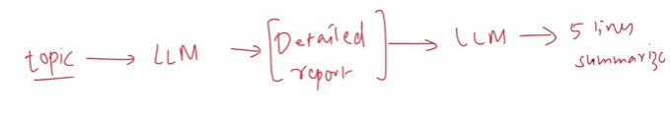

7.2 Traditional Approach (Without Output Parser)
Steps:
- Generate detailed report
- Extract using result.content
- Pass into second prompt
- Extract summary again
This requires manual handling of outputs.
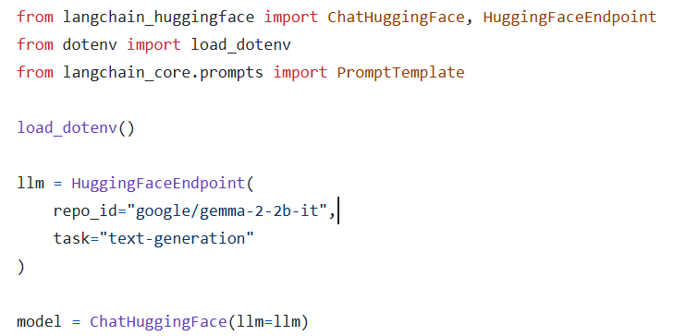
Now create the templates for the prompts

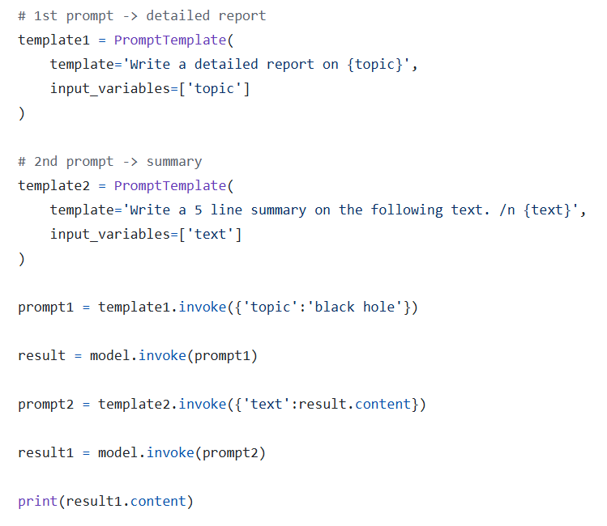
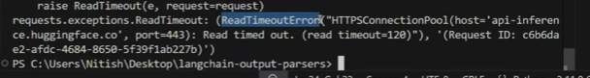
The above is the read time out error which occurs when hugging face api will not be working

8. Implementing the Same Flow Using String Output Parser
8.1 Key Concept: Chains
Chains allow connecting multiple steps into a single pipeline.
Basic flow:
Prompt Template → Model → Parser → Prompt Template → Model → Parser

8.2 Step-by-Step Pipeline Flow
- First prompt generates a detailed report
- Model processes it
- Parser extracts clean string
- Second prompt takes this string
- Model generates summary
- Parser extracts final output
Same code as above till creation of template
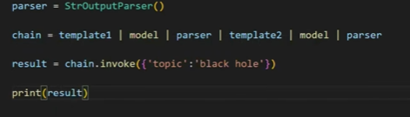

8.3 Benefits of Using Parser in Chains
- No manual extraction
- Clean data flow
- Easier maintenance

9. Model Flexibility
The String Output Parser works with:
- ChatOpenAI
- HuggingFace APIs
- Local models
The same chain code works across different models.

10. Key Takeaways from String Output Parser
10.1 Main Advantage
It enables smooth chaining of multiple LLM calls by:
- Removing metadata
- Passing clean text automatically
10.2 Why It Matters
Without parsers:
- Chains become complex
- Manual extraction is required
With parsers:
- Pipelines are simple and scalable
11. JSON Output Parser

11.1 Purpose of JSON Output Parser
The JSON Output Parser is used to force the LLM to return its response strictly in JSON format.
Key idea:
If your application expects JSON output, this parser is the quickest and simplest way to get it from an LLM.
Instead of receiving plain text, the model is instructed to respond with a JSON object.

11.2 Basic Working Principle
The parser does two main things:
- Provides format instructions to the LLM
- Parses the returned JSON string into a Python dictionary
This ensures:
- The LLM knows what output format is required
- The final output becomes machine-usable data

12. Creating a Prompt Using JSON Output Parser

12.1 Creating the Parser Object
First, an instance of JSON Output Parser is created.
This object is responsible for:
- Generating formatting instructions
- Parsing the final output
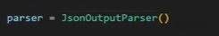

12.2 Using PromptTemplate with Format Instructions
A prompt template is created with:
- A static question
- A placeholder for format instructions
Example prompt content:
Give me the name, age, and city of a fictional person.
{format_instructions}
In this when we are creating the prompt template we will send additional information to the parser – Here we are sending the format instruction
And get_format_instructions() says what type of input instruction it is
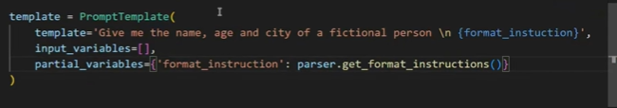

12.3 Using Partial Variables
Instead of user input, format instructions are passed as a partial variable.
Why partial variables?
Because:
- They are filled before runtime
- The user does not provide them
- They come directly from the parser
The value of format_instructions is generated using:
parser.get_format_instructions()

12.4 Concept Behind Format Instructions
Whenever you use:
- JSON Output Parser
- Structured Output Parser
- Pydantic Output Parser
You send additional instructions to the LLM describing:
- The required output format
These instructions are automatically generated by the parser.
This avoids manually writing:
Return a JSON object
and ensures consistency across different parsers.

13. Generating and Viewing the Prompt

13.1 Formatting the Prompt
The prompt is created using:
template.format()
Since no input variables exist, nothing is passed.
This creates a static prompt.

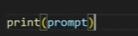

13.2 Example of Final Prompt Sent to LLM
The actual prompt sent looks like:
Give me the name, age, and city of a fictional person.
Return a JSON object.
The second line is automatically injected from:
get_format_instructions()

13.3 Why This Approach Is Preferred
Although you could manually write:
Return a JSON object
Using parser instructions is better because:
- It stays consistent with other parsers
- It scales when schemas become complex
- It follows LangChain best practices

14. Calling the Model and Parsing the Response

14.1 Getting Raw Response
The prompt is sent to the model.
The returned content already appears in JSON-like format.
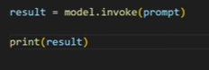

14.2 Parsing the JSON Output
The raw response is parsed using:
parser.parse(result.content)
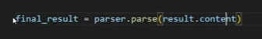

14.3 Final Parsed Output
The final output becomes a Python dictionary.
Example:
{
"name": "John",
"age": 28,
"city": "New York"
}

14.4 Data Type Confirmation
The parsed output is:
- Not a string
- A Python dictionary (JSON object equivalent)
This allows easy access like:
final_result["name"]

15. Simplifying the Code Using Chains

15.1 Traditional Approach
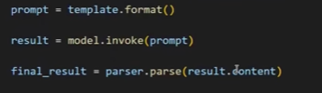
Without chains:
- Create prompt
- Call model
- Get result
- Parse manually

15.2 Using LangChain Chains
With chains:
chain = template | model | parser
result = chain.invoke({})
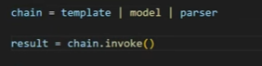

15.3 What Happens Behind the Scenes
The chain automatically:
- Builds the prompt
- Sends it to the model
- Receives response
- Calls parser.parse() internally
This makes the code:
- Shorter
- Cleaner
- Easier to maintain

15.4 Important Note on invoke()
Even if there are no input variables:
You must still pass an empty dictionary:
chain.invoke({})
Otherwise, an error occurs.
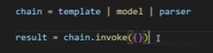

16. Major Limitation of JSON Output Parser

16.1 No Schema Enforcement
The biggest drawback of JSON Output Parser is:
It cannot enforce a fixed structure (schema).
The LLM decides:
- Keys
- Nesting
- Format

16.2 Example Problem
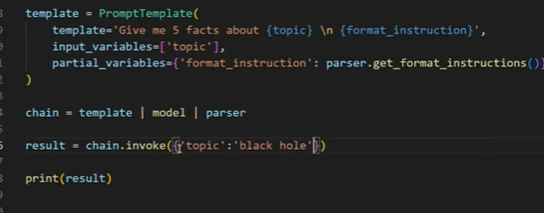
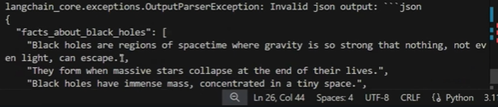
If you ask:
Give me five facts about black holes.
The LLM may return:
{
"facts_about_black_holes": [
"Fact 1",
"Fact 2",
"Fact 3",
"Fact 4",
"Fact 5"
]
}
But you may want:
{
"fact1": "...",
"fact2": "...",
"fact3": "...",
"fact4": "...",
"fact5": "..."
}
JSON Output Parser does not guarantee this structure.

16.3 Why This Is a Problem
- Output structure varies
- Hard to rely on for strict systems
- No validation

17. When NOT to Use JSON Output Parser
Avoid using it when:
- You need fixed keys
- You need validation
- You need schema consistency

18. When to Use JSON Output Parser
It is best for:
- Quick JSON extraction
- Flexible structures
- Simple use cases

19. Transition to Structured Output Parser
To solve the schema enforcement problem, LangChain provides:
👉 Structured Output Parser
This parser allows:
- Defining exact output structure
- Forcing LLM to follow schema
The next section focuses on this.
20. Structured Output Parser

20.1 Definition
The Structured Output Parser is an output parser in LangChain that extracts structured JSON data from LLM responses based on predefined field schemas.
Key difference from JSON Output Parser:
- JSON Output Parser only forces JSON format
- Structured Output Parser enforces a specific JSON structure (schema)

20.2 Main Advantage
It allows schema enforcement.
You define in advance:
- What fields should exist
- Their names
- Their purpose
The LLM is forced to follow this structure.

20.3 When to Use Structured Output Parser
Use it when:
- You need fixed keys in output
- Output structure must be consistent
- You do not require strict data type validation

21. Importing Structured Output Parser

21.1 Important Library Location
Unlike previous parsers that were imported from langchain_core, the Structured Output Parser is imported from:
langchain.output_parsers
along with:
ResponseSchema
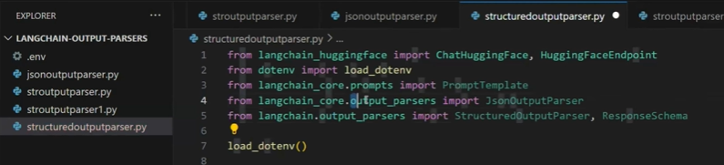

21.2 Why It Is Not in langchain_core
- langchain_core contains only the most reusable core components
- Structured Output Parser is part of the main LangChain umbrella library
This design keeps core lightweight.

22. Defining the Output Schema

22.1 Using ResponseSchema
The schema is created using a list of ResponseSchema objects.
Each ResponseSchema defines:
- Field name
- Field description
Till invoking the model the code remains the same
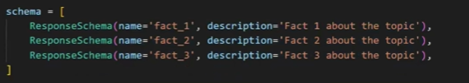

22.2 Example Schema: Generating Three Facts
Three schema objects are created:
- fact_1 – First fact about the topic
- fact_2 – Second fact about the topic
- fact_3 – Third fact about the topic
This tells the LLM:
Return three separate fields, not a list.

23. Creating the Structured Output Parser

23.1 Using from_response_schemas()
The parser is created using:
StructuredOutputParser.from_response_schemas(schema_list)
Where schema_list contains all ResponseSchema objects.

23.2 Result
The parser now:
- Knows the expected structure
- Can generate format instructions
- Can parse structured responses

24. Creating Prompt Template with Schema Instructions

24.1 Prompt Structure
The prompt contains:
- Main instruction:
Give three facts about the topic.
- Format instructions placeholder:
{format_instructions}
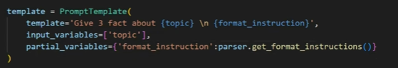

24.2 Input Variables
- topic

24.3 Partial Variables
Format instructions are passed using:
parser.get_format_instructions()

25. Running the Model and Parsing Output

25.1 Generating Prompt
The prompt is formatted by passing:
topic = "Black Hole"

25.2 Calling the Model
The formatted prompt is sent to the LLM.
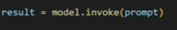

25.3 Parsing the Response
The response content is parsed using:
parser.parse(result.content)
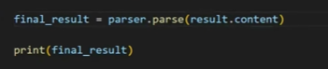

25.4 Final Output Example
{
"fact_1": "...",
"fact_2": "...",
"fact_3": "..."
}
The output strictly follows the predefined schema.

26. Using Structured Output Parser with Chains

26.1 Chain Format
chain = template | model | parser
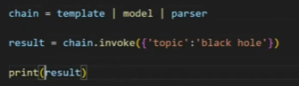

26.2 Invoking Chain
result = chain.invoke({"topic": "Black Hole"})

26.3 Benefit
- No manual prompt creation
- No manual parsing
- Clean and concise code

27. Advantages of Structured Output Parser

27.1 Schema Enforcement
Forces LLM to follow:
- Field names
- Output structure

27.2 Consistent Output
Always returns the same structured format.

28. Limitation of Structured Output Parser

28.1 No Data Validation
It cannot:
- Enforce data types
- Apply constraints

28.2 Example Problem
If schema expects:
Age as a integer
but LLM returns:
"35 years" – Years is a string here
It will still accept it.
No automatic correction or validation occurs.

28.3 Summary of Limitation
Structured Output Parser:
Enforces structure only, not correctness of data types.

29. Introduction to Pydantic Output Parser

29.1 Definition
Pydantic Output Parser is a structured output parser that uses Pydantic models to enforce:
- Schema structure
- Data type validation
- Constraints
We were passing the schema before. In the Pydantic output parser we will send the pydantic object

29.2 Main Advantage
It provides:
- Strict schema enforcement
- Automatic data validation
- Type safety

30. Core Features of Pydantic Output Parser

30.1 Strict Schema Enforcement
Defines exact fields and structure.

30.2 Type Safety
Ensures:
- Correct data types
- Optional type coercion

30.3 Validation
Applies:
- Value constraints
- Custom rules

30.4 Seamless Integration
Works smoothly with:
- LangChain chains
- Other components

31. Creating Pydantic Schema Model

31.1 Defining the Pydantic Class
A class is created that inherits from:
BaseModel

31.2 Fields Defined
Example fields:
- name: string
- age: integer (greater than 18)
- city: string
Each field includes:
- Type
- Description
- Constraints
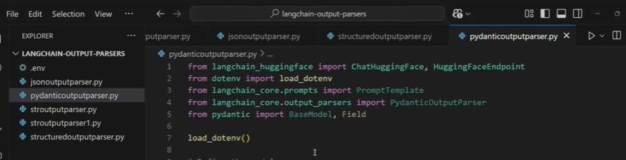
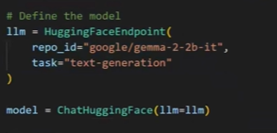
Creating the pydantic class and we can create objects of it
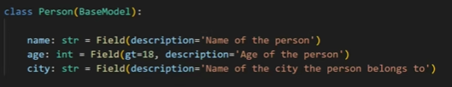

32. Creating Pydantic Output Parser

32.1 Initializing Parser
The parser is created using:
PydanticOutputParser(pydantic_object=Person)
Where Person is the Pydantic model.
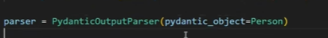

33. Creating Prompt with Format Instructions

33.1 Prompt Content
Generate the name, age, and city of a fictional {place} person.
{format_instructions}
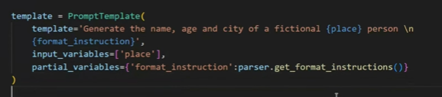

33.2 Input Variable
- place

33.3 Partial Variable
Format instructions provided by:
parser.get_format_instructions()

34. Running and Parsing Output

34.1 Invoke Prompt
place = "Indian"

34.2 Call Model
Send prompt to LLM.
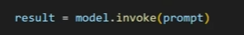

34.3 Parse Result
parser.parse(result.content)
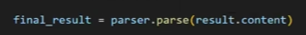

34.4 Final Output
Returns a validated Pydantic object:
Person(
name="...",
age=25,
city="..."
)

35. Viewing the Full Prompt Sent to LLM

The automatically generated prompt includes:
- User instruction
- Detailed JSON schema
- Validation rules
This ensures:
- Correct structure
- Correct data types
Print(prompt)
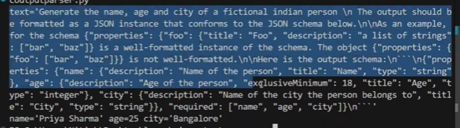

36. Using Pydantic Output Parser with Chains

36.1 Chain Setup
chain = template | model | parser

36.2 Invocation
final_result = chain.invoke({"place": "Sri Lankan"})
print(final_result)

36.3 Benefit
- Much cleaner code
- Automatic validation
- Automatic parsing

37. Comparison of All Four Output Parsers

Parser | Structure | Schema Enforcement | Validation | Best Use Case
String Output Parser | No | No | No | Clean text
JSON Output Parser | Yes | No | No | Quick JSON
Structured Output Parser | Yes | Yes | No | Fixed keys
Pydantic Output Parser | Yes | Yes | Yes | Production

38. Model Compatibility
All parsers work with:
- HuggingFace models
- OpenAI models
- Claude
- Gemini
- Local LLMs

39. Other Available Output Parsers
LangChain provides many additional parsers such as:
- CSV Output Parser
- List Output Parser
- Markdown Output Parser
- Datetime Output Parser
- Output Fixing Parser
These can be explored in official documentation.

40. Final Summary
- String Output Parser → Clean text for chains
- JSON Output Parser → Flexible JSON without schema
- Structured Output Parser → Fixed JSON structure
- Pydantic Output Parser → Structured + validated data

